Intro On L1Calo

Jacky Li, Peter Camporeale

May 2023

<Peter: your input is greatly appreciated in this part. ---Jacky>

Part of our responsibilities as CIS tech is helping monitor problematic channels and towers (groupings of 5 or 6 channels) for the Tile Calorimeter and for the L1 Calo trigger.

If you have taken experimental physics at any point, you should know what a trigger is. (Still, this does not justify taking the class.)

Triggers are hardware-level logic devices to decide which events to record out of the millions that happen per second. The [Level 1 Calo (L1 Calo) trigger](https://twiki.cern.ch/twiki/bin/view/Atlas/TileCalLvl1Trigger) combines the Tile Calorimeter and the Liquid Argon (LAr) Calorimeter to look for jets and stuff (M , David Miller are good people to talk to). In practice, it is a slice of a Tile Module will get paired up with a slice of a LAr module and the combined energy is used to look for large groups of particles going through.

Combined L1Calo + Tile calibration runs are taken weekly at Point 1 (ATLAS control room). You will probably take them yourself once you become a shifter. There are two types of calibrations runs taken and both of them use the charge injection system. “Energy scans” are analyzed by the L1Calo group while “[PMT scans](https://twiki.cern.ch/twiki/bin/viewauth/Atlas/TileTriggerBadChannels)” are analyzed by CIS techs. For both runs, simulating signals from a PMT, a capacitor injects charge in the 3in1card in the PMT, and then the trigger signal from the low gain is analyzed. For energy scans, charge is injected at the same time for all PMTs and this injected charge is varied. For PMT scans the injected charge is constant at 100 pC and charge is injected for one PMT in a tower at a time. So first, charge is injected for PMT1 in all towers, then charge is injected in PMT2 for all towers, and so on. We look at the response of these scans to see the misbehaving PMTs. The geometry of the trigger towers is shown [here](http://hep.uchicago.edu/atlas/tilecal/level1/geometry.html). You can compare your problematic channels with a [list of L1Calo updates and remaining problems](https://twiki.cern.ch/twiki/bin/view/Atlas/LevelOneRemainingChanProbs) to see if the L1Calo team is unaware of any recent problems.

The calibration runs get reconstructed and processed automatically. You can find the [output here](https://pcata007.cern.ch/tile/l1calo/). If you open one of these folders you’ll see a bunch of files, mostly plots with a single text file. That text file keeps a record of problematic channels. For each PMT scan that gets taken, every 3in1 card receives a set amount of charge. That signal gets reconstructed down the each trigger read out scheme (Tile and L1Calo separately), and depending on the percentage of the expected response, we call a channel good or bad.

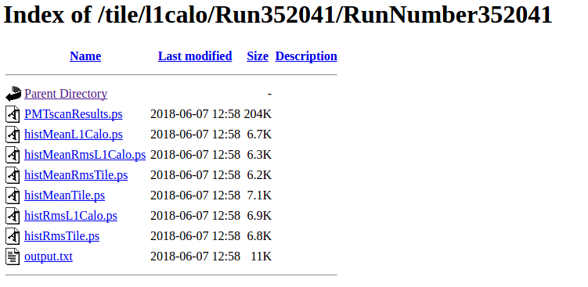

For example, 100pC gets injected into a specific Tile channel and gets read out through the Tile readout scheme and we recover 100% of the expected charge injected so everything looks normal in Tile. But there could be a problem in the cabling in the L1Calo system so they recover (relatively) 5% of the expected gain. So in our list that will show up as a bad channel in L1Calo, but completely fine in Tile. Channels can be zero gain (<10%) or low gain (<50%) in Tile or L1Calo - we keep track of all the relevant combinatorics over time.

When a tower looks bad, it often present two possibilities: either a problem in the Tile hardware, in which case we need to actually replace some parts of the Tile electronics, or a problem in L1Calo, in which case they need to do whatever it is they do. It’s our job to update the Tile leadership on these kinds of issues.

Right Now, we are in the middle of developing a new calibration method. [To be Added]

# TUCS

The automatic reconstruction available in the website above and below is the output of a TUCS macro called “triggerTest.py”. All this macro does is grab the gain values for L1Calo and Tile channels from TileReconstruction and plot the problem channels for quick checks. [More accurate notes needed]

# Example Plots

An automatic scan plot where Eta has the range [-1.5 , 1.5] and Phi corresponds to each module number:

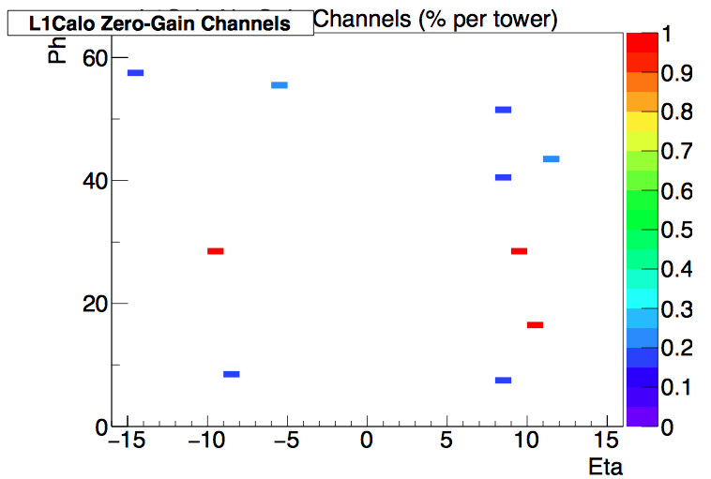

The fraction of zero gain channels per tower:

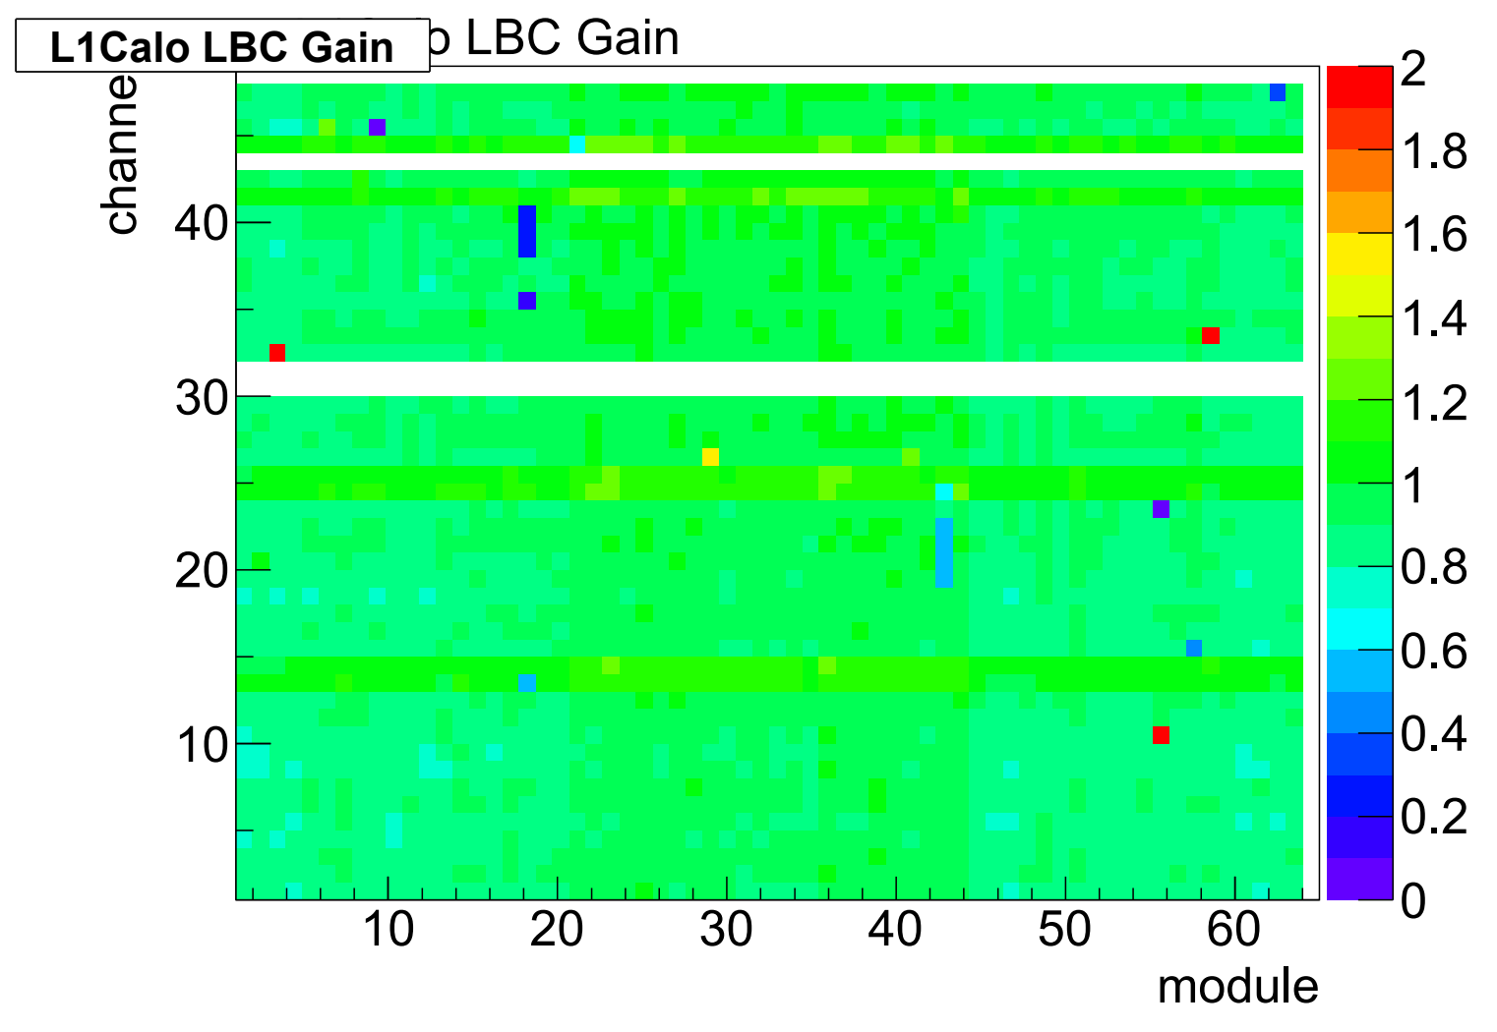

You can convert between Eta, Phi, module, and channel using [this tool](http://atlas.web.cern.ch/Atlas/SUB_DETECTORS/TILE/EtaPhiConverter/converter.html).